## Knowledge Institute of Technology – Salem Tamilnadu

## CHATBOT-SEEK WORK

**PROJECT REPORT**

*Submitted by*

TEAM NAME (TECHNO STARS)

THIRISHA M

TRISHNA A

KOUSIKA S

YOMIKA S

*In a partial fulfilment for the award of the degree of*

BACHELOR OF ENGINEERING

In

ELECTRONICS AND COMMUNICATION ENGINEERING

**KNOWLEDGE INSTITUTE OF TECHNOLOGY,**

**SALEM-637504**

# PROJECT REPORT TITLES

1 INTRODUCTION

1.1 OVERVIEW

1.2 PURPOSE

2 LITERATURE SURVEY

3 PROBLEM STATEMENT

4 SOLUTION

5 TECHNOLOGIES USED

6 DATA COLLECTION

7 IMPLEMENTATION

8 RESULT

9 ADVANTAGES & DISADVANTAGES

10 CONCLUSION

11 BIBILOGRAPHY

12 APPENDIX

12.1 SOURCE CODE

# INTRODUCTION

# 1.1 OVERVIEW

Chatbots can be an invaluable tool for your next job search. A chatbot is a programmable browser-based or smartphone application that mimics human conversations. Many businesses use them to handle the most frequently asked questions, especially outside of business hours. Some chatbots act as screeners for in-demand positions. Advertised as a Career Concierge, the chatbot assists job seekers in determining appropriate career paths. It also lets you explore whether the positions you want most are currently available in your area. However, bots cannot comprehend about what the customer has planned. It is a very much common problem that must be tackled. Bots are generally trained according to the past information which is only available to them. So in most of the organizations, chatbot maintains their logs of discussions so that they can understand their customers behaviour. A job searching chatbot is an AI-powered virtual assistant designed to help individuals navigate the complexities of finding employment. This innovative technology leverages Natural Language Processing (NLP) and other AI techniques to engage with users in a conversational manner, providing personalized support and guidance throughout the job search process. With the rapid advancement of technology and the evolving job market, job seekers often encounter challenges such as sifting through numerous job listings, tailoring their resumes and cover letters, and staying updated on the latest opportunities Chatbots are smart, but they work best when you provide the most specific information possible. Before you start using one, think about the kind of job you want. Also, consider your geographic range. The chatbot assists job seekers in determining appropriate career paths. It also lets you explore whether the positions you want most are currently available in your area. The chatbot can be accessed via the company’s website or Messenger.

# 1.2 PURPOSE

The purpose of our chatbot lies in their ability to interact with users in a conversational manner, automate tasks, provide real-time assistance and enhance user experience across various domains and industries. Likewise, our chatbot offer several unique qualities and advantage that distinguish them from traditional software application and contribute to their popularity and versatility.

**\*** To a great degree, this part is differ from all bot in the sense of this chatbot is to focus on rural side area people who searching for job or the students who need of internships. But you can doubt that how we include all the rural areas, that's why we particularly select '5' small-districts for basic adaption . In future, further we try to include all the small- cities of districts.

**\***In chatbot-seek-work, the queries and request are differ from other bots, based on their qualification need , we divide that into categories such as (INTERNSHIP,FULL-TIME EMPLOYEMENT) on their basis user can easy to choose what they excepted.

**\***It also track or get the location information from user to show the nearby companies and the main advantage is we also give a career objection for user to get the job role position in that company, from this they can also know the value or importance of the role.

**\*** In this platform we also include the reviews & ratings of top rated companies in near-by and also their contact details, e-mail web. So, this may give a clear-cut clarity to user to select their job in their home-town as excepted company.

# LITERATURE SURVEY

A literature survey on the topic of chatbots for job search reveals a range of studies, research papers, and articles that explore the application of chatbots in the field of job searching and recruitment. These resources provide insights into the development, effectiveness, and impact of chatbots in assisting job seekers throughout their job search process.

**1. Chatbot for Career Guidance:**

Chatbots have been employed as career advisors, helping job seekers identify suitable career paths, industries, and job roles based on their skills, qualifications, and preferences. These chatbots provide personalized recommendations and offer guidance on skill development and training.

**Reference:**

Hossain, M. S., & Shahriar, A. (2018). "A Chatbot-based Career Consultation System using Expert System." International Journal of Computer Applications, 181(45), 1-5.

**2. Job Matching and Recommendations:**

Chatbots utilize natural language processing and machine learning algorithms to match job seekers with suitable job openings based on their skills, experience, and preferences. These systems enhance the job search process by providing personalized job recommendations.

**Reference:**

Goel, S., & Janghel, R. R. (2021). "Chatbot for Job Recruitment and Job Hunting." International Journal of Advanced Research in Computer Science and Software Engineering, 11(2), 125-131

# PROBLEM STATEMENT

**Chatbot Development:** Design and develop an AI-powered chatbot capable of providing assistance and support in job searching.

The chatbot will utilize Flask, a web framework for Python, to develop the backend infrastructure of the chatbot. Incorporate OpenAI GPT or a similar NLP API to understand and respond effectively to user queries. Implement sentiment analysis API to extract emotional insights from conversations, enabling the chatbot to provide empathetic and personalized support. Utilize Twilio API or a similar solution for sending SMS or phone notifications to support staff in high-risk situations. In today's dynamic job market, individuals often face challenges in effectively navigating the process of finding suitable employment opportunities. The sheer volume of job listings, the need to tailor application materials for different roles, and the requirement to stay updated on industry trends and skills demand can overwhelm job seekers. This solution aims to address these challenges by creating a job searching chatbot that empowers users with tailored assistance, interview preparation, skill enhancement suggestions, application tracking, and emotional support, ultimately streamlining the job search process and increasing users' likelihood of finding suitable and fulfilling job opportunities.

# SOLUTION

To address the challenges faced by job seekers in the modern employment landscape, we propose the development of a comprehensive Job Searching Chatbot powered by AI and NLP technologies. In a digital world, customers have come to expect business to be available '24/7'.But in reality, no one is available to interact with the customers. To overcome these crises, Chatbot is created to process and simulate human conversation individually, Chatbot is like a conversational tool that provides an easy and inexpensive way to do just that, by adding an automated live chat feature to the website that visitors can interact with to get the help they need when they need it. There are many individual chatbots available for various domains, Besides the job-related chatbot are necessary for many youngsters but many of the bots are unpopular among job seekers due to their ordinary features like the IQ level of the AI being comparatively low and also it didn't provide the information what a user needed. Likewise, the user might be from urban areas, rural areas/country-sides, and cities. Rural people/workers,those who are located outside of a major city or town, can often find themselves with lack of high-quality employment opportunities. Rural workers who use flexible and remote work can find themselves with a much larger pool of opportunities while being able to stay close to home. "FlexJobs believes flexible work" can have a position impact on rural workers. we have shown our support to build a chatbot for job seekers in rural areas, and also many women would like to work in their Home-Town. There is no proper guidance for them to seek jobs in nearby areas. That's the reason why our chatbot is specifically built.

# TECHNOLOGIES USED

***PYTHON:***

Python is a popular programming language for developing chatbots for job searching because it has natural language processing capabilities,integrationwith various platforms,and theability to rapidly prototypeand iterate. Python also has a vast array of libraries, frameworks**,** and data abstraction tools that make it easy to build chatbots with different functionality.

***FLASK:***

Flask is a microframework used for web development .Used to integrate your chatbot withDialog flow, a platform that provides natural language understanding and conversational AI. This way, you can make your chatbot more intelligent and responsive.

***OPEN AI:***

OpenAI is an AI research laboratory that develops large-language models, such as ChatGPT, that can generate natural and coherent text based on user input.

***NATURAL LANGUAGE PROCESSING(NPL):***

NLP is a branch of AI that enables computers to analyze, comprehend, and derive meaning from natural language in an intelligent and useful way. NLP is essential for developing chatbots for job searching.

***JAVA SCRIPT:***

We create a website by using java script. Basically, creating a website with the help of javascript involves several steps, including setting up the HTML structure, styling with CSS, and adding interactivity with JavaScript.

# DATA COLLECTION

**1.Job Listings Databases:**

Integrate with job boards and platforms like LinkedIn, Indeed, Glassdoor, and Monster to access a wide range of job listings.Use web scraping techniques to gather data from company websites that may not be available through APIs.

**2.Industry Insights and Trends:**

Incorporate APIs or data feeds that provide insights into industry trends, job growth, skills demand, and salary information. Utilize government labor statistics websites to gather data about job sectors, unemployment rates, and emerging industries.

**3.Skill Requirements**:

Analyze job descriptions to identify common skills and qualifications required for specific roles. Use natural language processing to extract key skills and requirements from job postings.

**4.User Profiles and Preferences**:

Collect user input on skills, experience, preferred job roles, industries, and location. Utilize user interactions with the chatbot to understand preferences and tailor recommendations.

**5.Company Insights:**

Gather data about companies, including their cultures, missions, values, employee reviews, and growth prospects. Use APIs or web scraping to retrieve company-related information.

**6.Skill Enhancement Resources:**

Aggregate data about online courses, certifications, and learning platforms that offer skill enhancement opportunities. Ensure that the resources are reliable and up-to-date.

# IMPLEMENTATION

“The implementations of a chatbot involve a variety of techniques.”

The requirements for designing a chatbot include accurate knowledge representation, an answer generation strategy, and a set of predefined neutral answers to reply when user utterance is not understood. The first step in designing any system is to divide it into constituent parts according to a standard so that a modular development approach can be followed.

The process starts with a user’s request, for example, “What are the jobs are available?”, to the chatbot After the chatbot receives the user request, the Language Understanding Component parses it to infer the user’s intention and the associated information.Once a chatbot reaches the best interpretation it can, it must determine how to proceed. It can act upon the new information directly, remember whatever it has understood and wait to see what happens next, require more context information or ask for clarification. When the request is understood, action execution and information retrieval take place. The chatbot performs the requested actions or retrieves the data of interest from its data sources, which may be a database, known as the Knowledge Base of the chatbot, or external resources that are accessed through an API call. Upon retrieval, the Response Generation Component uses Natural Language Generation (NLG) to prepare a natural language human-like response to the user based on the intent and context information returned from the user message analysis component. The appropriate responses are produced by one of the three models: rule-based, retrieval based, and generative model. A Dialogue Management Component keeps and updates the context of a conversation which is the current intent, identified entities, or missing entities required to fulfill user requests. Moreover, it requests missing information, processes clarifications by users, and asks follow-up questions.

# RESULT

# 

# 

# 

# 

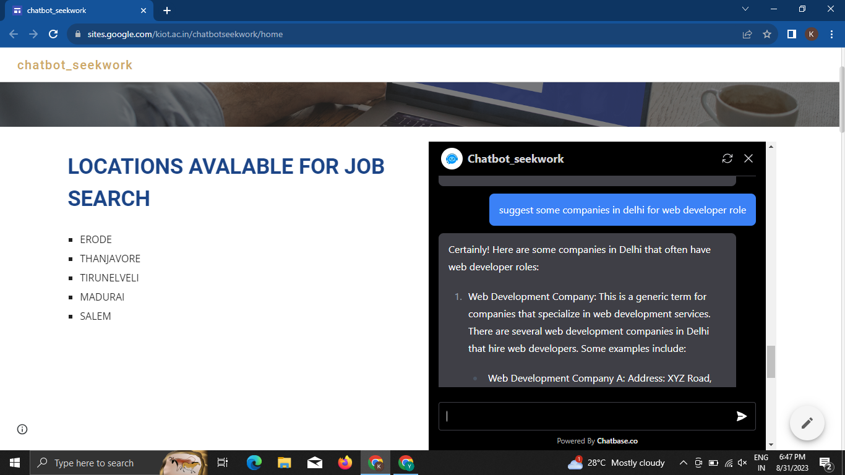

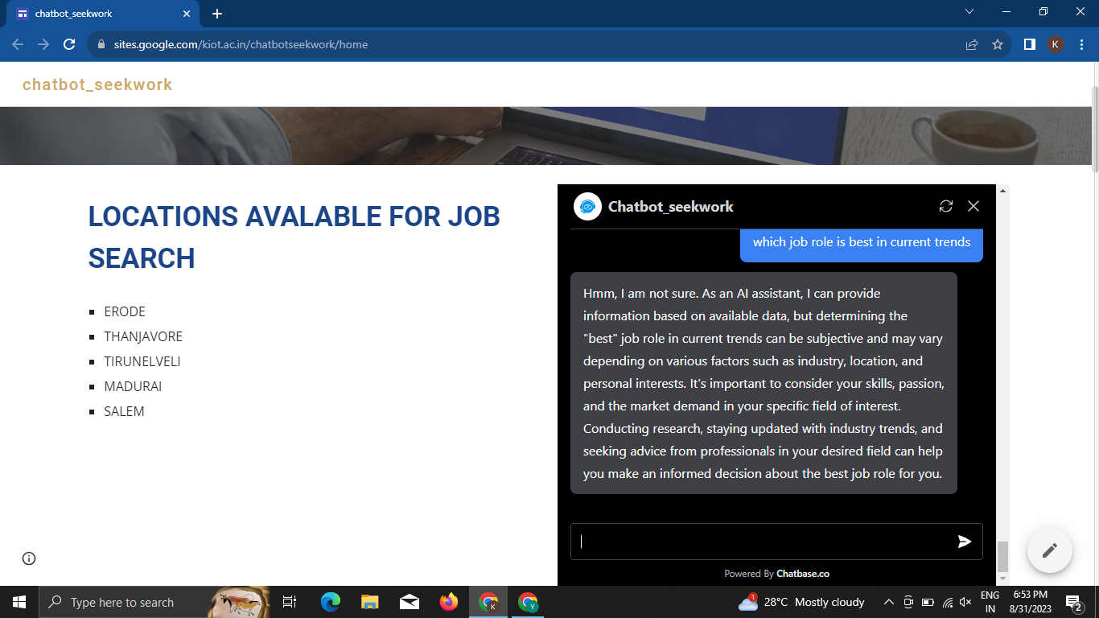

# ADVANTAGES & DISADVANTAGES

## ADVANTAGES:

* Mainly for users from rural areas.
* 24/7 Availability.
* Understands human language.
* Instant response for any quires.
* Perfect for repetitive quires.
* Reduce operational cost.
* User friendly.

## DISADVANTAGES:

* Higher misunderstanding.
* Not satisfy angry users.
* Job search availability is enabled for mentioned locations only.
* It’s not for all businesses.

# CONCLUSION

Chatbot can be useful and convenient tools for finding jobs and getting hired, but they are instant solutions. Chatbot can help you by answering simple questions, providing personalized recommendations, and scheduling interviews, but they also require you to be precise, patient, and flexible in your interactions. Chatbot can also improve over time by learning from your feedback and preferences. Using our chatbot user can easily get high quality support and conflict resolution a any time of day and also for large quantity of users simultaneously.

# BIBILOGRAPHY

CHATBOTS MAGAZINE- <https://chatbotsmagazine.com/>

LANDBOT- <https://landbot.io/blog/recruitment-chatbot>

G2- <https://www.g2.com/articles/how-to-build-a-chatbot>

FORBES- <https://www.forbes.com/>

KAGGLE- <https://www.kaggle.com/>

GITHUB- <https://github.com/>

# APPENDIX

## SOURCE CODE:

from flask import Flask, render_template, request, jsonify

from transformers import AutoModelForCausalLM, AutoTokenizer

import torch

tokenizer = AutoTokenizer.from_pretrained("microsoft/DialoGPT-medium")

model = AutoModelForCausalLM.from_pretrained("microsoft/DialoGPT-medium")

app = Flask(__name__)

@app.route("/")

def index():

return render_template('chat.html')

@app.route("/get", methods=["GET", "POST"])

def chat():

msg = request.form["msg"]

input = msg

return get_Chat_response(input)

def get_Chat_response(text):

# Let's chat for 5 lines

for step in range(5):

# encode the new user input, add the eos_token and return a tensor in Pytorch

new_user_input_ids = tokenizer.encode(str(text) + tokenizer.eos_token, return_tensors='pt')

# append the new user input tokens to the chat history

bot_input_ids = torch.cat([chat_history_ids, new_user_input_ids], dim=-1) if step > 0 else new_user_input_ids

# generated a response while limiting the total chat history to 1000 tokens,

chat_history_ids = model.generate(bot_input_ids, max_length=1000, pad_token_id=tokenizer.eos_token_id)

# pretty print last ouput tokens from bot

return tokenizer.decode(chat_history_ids[:, bot_input_ids.shape[-1]:][0], skip_special_tokens=True)

if __name__ == '__main__' ; app.run()

<link href="//maxcdn.bootstrapcdn.com/bootstrap/4.1.1/css/bootstrap.min.css" rel="stylesheet" id="bootstrap-css">

<script src="//maxcdn.bootstrapcdn.com/bootstrap/4.1.1/js/bootstrap.min.js"></script>

<script src="//cdnjs.cloudflare.com/ajax/libs/jquery/3.2.1/jquery.min.js"></script>

<!DOCTYPE html>

<html>

<head>

<title>Chatbot</title>

<link rel="stylesheet" href="https://stackpath.bootstrapcdn.com/bootstrap/4.1.3/css/bootstrap.min.css" integrity="sha384-MCw98/SFnGE8fJT3GXwEOngsV7Zt27NXFoaoApmYm81iuXoPkFOJwJ8ERdknLPMO" crossorigin="anonymous">

<link rel="stylesheet" href="https://use.fontawesome.com/releases/v5.5.0/css/all.css" integrity="sha384-B4dIYHKNBt8Bc12p+WXckhzcICo0wtJAoU8YZTY5qE0Id1GSseTk6S+L3BlXeVIU" crossorigin="anonymous">

<script src="https://ajax.googleapis.com/ajax/libs/jquery/3.3.1/jquery.min.js"></script>

<link rel="stylesheet" type="text/css" href="{{ url_for('static', filename='style.css')}}"/>

</head>

<body>

<div class="container-fluid h-100">

<div class="row justify-content-center h-100">

<div class="col-md-8 col-xl-6 chat">

<div class="card">

<div class="card-header msg_head">

<div class="d-flex bd-highlight">

<div class="img_cont"

<img src="https://i.ibb.co/fSNP7Rz/icons8-chatgpt-512.png" class="rounded-circle user_img">

class="online_icon"></span>

</div>

<div class="user_info" <span>ChatBot</span>

<p>Ask me anything!</p>

<div id="messageFormeight" class="card-body msg_card_body">

<div class="card-footer">

<form id="messageArea" class="input-group">

<input type="text" id="text" name="msg" placeholder="Type your message..." autocomplete="off" class="form-control type_msg" required/>

<div class="input-group-append">

<button type="submit" id="send" class="input-group-text send_btn"><i class="-location-arrow"></i></button>

</div>

</form>

</div>

</div>

<script>

$(document).ready(function() {

$("#messageArea").on("submit", function(event) {

const date = new Date();

const hour = date.getHours();

const minute = date.getMinutes();

const str_time = hour+":"+minute;

var rawText = $("#text").val();

$("#text").val("");

$("#messageFormeight").append(userHtml);$.ajax({

data: msg: rawText,

});

});

</script>

</body>

</html>